DAYANANDA SAGAR UNIVERSITY
Devarakaggalahalli, Harohalli
Kanakapura Road, Ramanagara - 562112, Karnataka, India



Bachelor of Technology
in
COMPUTER SCIENCE AND ENGINEERING

Minor Project Report

( Machine Learning Models for Predicting CO2 Solubility in Brine Systems for Carbon Geostorage Applications)

Batch: 134

By
Madhu Sudhan Reddy S - ENG23CS0659
Bhavana S - ENG23CS0034
Ranjita Mugali - ENG24CS1015
Bindu Malagi - ENG24CS1004

Under the supervision of
Dr. Natarajan Venkateswaran
Designation and Department of Guide

DEPARTMENT OF COMPUTER SCIENCE & ENGINEERING
SCHOOL OF ENGINEERING
DAYANANDA SAGAR UNIVERSITY
(2025-2026)


School of Engineering
Department of Computer Science & Engineering
Devarakaggalahalli, Harohalli, Kanakapura Road, Ramanagara - 562112

Karnataka, India

CERTIFICATE

This is to certify that the minor project work titled “Machine Learning Models for Predicting CO2 Solubility in Brine Systems for Carbon Geostorage Applications” is carried out by Madhu Sudhan Reddy S (ENG23CSO659), Bhavana S (ENG23CS0034), Ranjita Mugali (ENG24CS1015), Bindu Malagi(ENG241004), bonafide students of Bachelor of Technology in Computer Science and Engineering at the School of Engineering, Dayananda Sagar University, Bangalore in partial fulfillment for the award of degree in Bachelor of Technology in Computer Science and Engineering, during the year 2025-2026.

Dr. Natarajan Venkateswaran | Dr. Girisha G S | Dr. Udaya Kumar Reddy K R
Assistant/Associate/ Professor  Dept. of CS&E,  School of Engineering  Dayananda Sagar University  Date: | Chairman CSE  School of Engineering  Dayananda Sagar University  Date: | Dean  School of Engineering  Dayananda Sagar University  Date:

Name of the Examiner Signature of Examiner

<
DECLARATION
We, Name1 (USN), Name2 (USN), Name2 (USN), Name3 (USN), Name4 (USN), are students of eighth semester B. Tech in Computer Science and Engineering, at School of Engineering, Dayananda Sagar University, hereby declare that the Minor Project titled “Title” has been carried out by us and submitted in partial fulfilment for the award of degree in Bachelor of Technology in Computer Science and Engineering during the academic year 2024-2025.
Student | Signature

Name1: Madhu Sudhan Reddy S

USN : ENG23CS0659

Name2: Bhavana S

USN : ENG23CS0034

Name3: Ranjita Mugali

USN : ENG24CS1015

Name4: Bindu Malagi

USN : ENG24CS1004

Place : Bangalore

Date :

ACKNOWLEDGEMENT

It is a great pleasure for us to acknowledge the assistance and support of many individuals who have been responsible for the successful completion of this project work.
First, we take this opportunity to express our sincere gratitude to School of Engineering & Technology, Dayananda Sagar University for providing us with a great opportunity to pursue our Bachelor’s degree in this institution.
We would like to thank Dr. Udaya Kumar Reddy K R, Dean, School of Engineering, Dayananda Sagar University for his constant encouragement and expert advice.
It is a matter of immense pleasure to express our sincere thanks to Dr. Girisha G S, Department Chairman, Computer Science and Engineering, Dayananda Sagar University, for providing right academic guidance that made our task possible.

We would like to thank our guide Dr. Natarajan Venkateswaran Associate / Assistant/ Professor, Dept. of Computer Science and Engineering, Dayananda Sagar University, for sparing his/her valuable time to extend help in every step of our project work, which paved the way for smooth progress and fruitful culmination of the project.

We would like to thank our Project Coordinators as well as all the staff members of Computer Science and Engineering for their support.
We are also grateful to our family and friends who provided us with every requirement throughout the course.
We would like to thank one and all who directly or indirectly helped us in the Project work.

TABLE OF CONTENTS
Page

LIST OF ABBREVIATIONS ................................................................................. 6
LIST OF FIGURES ……….................................................................................... 7
LIST OF TABLES ………….................................................................................. 7
ABSTRACT .....................................................................................................… 8

CHAPTER 1 INTRODUCTION
1.1. INTRODUCTION
1.1.1. OBJECTIVE
1.3. SCOPE....................................................................................................… 9…12
CHAPTER 2 PROBLEM DEFINITION ………................................................… 13…14
CHAPTER 3 LITERATURE SURVEY................................................................... 15…17
CHAPTER 4 REQUIREMENTS ................................................................................
4.1. FUNCTIONAL REQUIREMENTS ............................................................
4.2. NON-FUNCTIONAL REQUIREMENTS ................................................
4.3. HARDWARE AND SOFTWARE REQUIREMENTS....................................
CHAPTER 5 DESIGN & METHODOLOGY.............................................................
CHAPTER 6 RESULTS AND DISCUSSION….......................................................
6.1 RESULTS ............................................ ............. ........... ........................
6.2 DISCUSSION OF RESULTS ........................................................................
CHAPTER 7 CONCLUSION AND FUTURE WORK
7.1. CONCLUSION.................................................................................... ……….
7.1. SCOPE FOR FUTUREWORK ............................................................

REFERENCES... .......................................................................................................

APPENDIX A ............................................................................................................
SAMPLE CODE ..............................................................................................
LIST OF ABBREVIATIONS
RF | Random Forest
XGBoost | Extreme Gradient Boosting
DT | Decision Tree
R² | Coefficient of Determination
RMSE | Root Mean Square Error
MAE | Mean Absolute Error
CO₂ | Carbon Dioxide
pCO₂ | Partial Pressure of Carbon Dioxide
CO₃²⁻ | Carbonate Ion
HCO₃⁻ | Bicarbonate Ion

LIST OF FIGURES
Fig. No. | Description of the figure | Page No.
1. | System Architecture of CO₂ Prediction Model
2 | Architecture
3 | CO₂ Distribution Across Models
4 | HCO₃⁻ Distribution Across Models
5 | CO₃²⁻ Distribution Across Models
6 | Predicted vs Actual CO₂ Values
7 | Error Distribution
8 | Feature Importance
9 | Normalized Model Comparison

LIST OF TABLES
Table No. | Description of the Table | Page No.
1 | Model Performance Comparison
2 | Evaluation of result
3 | Test Case 1
4 | Test Case 2
5 | Test Case 3

Abstract
In order to assess the potential of carbon capture and storage (CCS) as a viable method to solve the problem of climate change, it is important to accurately predict how much carbon dioxide (CO2) will dissolve in brine systems. Traditional experimental methods to predict CO2 solubility in brine systems can be costly and take too long to perform. For this reason, researchers used machine learning algorithms to develop predictive models for CO2 solubility as a function of temperature, salinity, and CO2 partial pressure (pCO2). Various machine learning models including Extreme Gradient Boosting (XGBoost), Random Forest, and Decision Tree were developed and tested to see which performed the best. Model comparisons showed that the Random Forest produced the highest R2 value of 0.9927, and the lowest RMSE value of 0.008 were produced with the XGBoost model. Although both models provided accurate predictions of the CO2 solubility data set; the Decision Tree model was found to produce considerably less accurate results. All ensemble models provided better-fitting results than their single-model counterparts and demonstrated their ability to accurately capture the complex, non-linear relationship between CO2 solubility and independent variables through the use of ensembles is beneficial in developing accurate and reliable methods of predicting CO2 solubility for large-scale carbon geostorage applications.

CHAPTER 1
INTRODUCTION

This chapter presents an overview of the project titled “Prediction of CO₂ Solubility and Carbonate Ion Concentration Using Machine Learning Models.” The report is structured in a systematic manner, beginning with the introduction and concluding with the summary and conclusions. Each chapter is organized with appropriate sections and subsections to ensure clarity and logical presentation of the work.

The primary aim of this project is to develop an efficient and accurate predictive model for CO₂ solubility and carbonate ion concentration using machine learning techniques. The study focuses on analyzing complex environmental data and applying advanced computational methods to improve prediction performance. The content of this report follows proper formatting guidelines, including justified alignment and appropriate spacing for readability.
- INTRODUCTION:

Carbon dioxide (CO₂) is one of the most significant greenhouse gases contributing to global climate change and environmental imbalance. Its concentration in the atmosphere has increased rapidly due to industrialization, fossil fuel consumption, and human activities. The behavior of CO₂ in natural systems, particularly its solubility in water, plays a crucial role in regulating atmospheric carbon levels and maintaining ecological balance. CO₂ solubility directly influences ocean chemistry, marine life sustainability, and carbon capture processes.

Predicting CO₂ solubility is essential for various applications, including environmental monitoring, carbon capture and storage (CCS), and chemical engineering processes. Accurate prediction helps in understanding how CO₂ interacts with water under different temperature and pressure conditions. However, due to the complex and nonlinear relationships between influencing parameters, traditional prediction methods often fail to provide precise results.
  - Objective of the Project:

The main objective of this project is to predict CO₂ solubility and carbonate ion concentration using machine learning techniques. The project focuses on improving prediction accuracy compared to traditional methods.

It includes data analysis, implementation of different machine learning models, and comparison of their performance. The aim is to identify the most suitable model for accurate prediction.
    - Problem Statement

The prediction of CO₂ solubility and carbonate ion concentration is a complex problem due to the nonlinear interaction of various influencing parameters such as temperature, pressure, and chemical composition. Traditional thermodynamic and empirical models often fail to provide accurate results when dealing with large and complex datasets.

Previous research works have attempted to address this problem using different modeling techniques; however, they suffer from several limitations such as low prediction accuracy, inability to handle nonlinear relationships effectively, and lack of scalability.

Therefore, this project proposes the use of machine learning techniques to analyze data patterns and improve prediction performance. By comparing different models, the study aims to identify the most suitable approach for accurate and reliable prediction of CO₂ solubility.

- figures and Tables
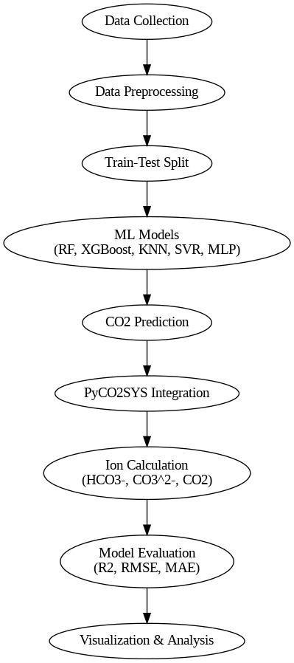

Figure 1. System Architecture of CO₂ Prediction Model

Table 1. Model Performance Comparison
Sl. No. | Model | R² | RMSE | MAE
1 | Random Forest | 0.971505 | 0.731134 | 0.469883
2 | XGBoost | 0.963358 | 0.829085 | 0.519421
3 | KNN | 0.952563 | 0.943337 | 0.609093
4 | CatBoost | 0.979197 | 0.624702 | 0.444586
5 | MLP | 0.890837 | 1.431027 | 1.091228
6 | LightGBM | 0.969000 | 0.762590 | 0.479954

- Scope

The scope of this project is to develop a machine learning-based system for predicting CO₂ solubility and carbonate ion concentration using available data. The system focuses on improving prediction accuracy and analyzing the performance of different models.

This project can be applied in environmental monitoring, carbon capture and storage systems, and chemical industries. It helps in understanding the behavior of carbon dioxide under different conditions.

The project also has environmental significance, as it contributes to better analysis of CO₂ levels, which is important for controlling pollution and addressing climate change.

CHAPTER 2
PROBLEM DEFINITION

2.1 Problem Definition

The prediction of CO₂ solubility and carbonate ion concentration is an important problem in environmental and chemical studies. These values depend on several parameters such as temperature, pressure, and composition of the system. Due to the interaction between these variables, the relationship becomes complex and nonlinear.

Traditional methods are not able to handle this complexity effectively, which leads to inaccurate predictions. Therefore, there is a need for a better approach that can analyze complex data and provide reliable results.

2.2 Existing System

In the existing system, CO₂ solubility is predicted using thermodynamic and mathematical models. These models are based on fixed equations and assumptions.

However, these methods have several drawbacks:
- They cannot handle large and complex datasets efficiently
- They fail to capture nonlinear relationships between variables
- The prediction accuracy is often low
- They require high computational effort for complex calculations

2.3 Proposed System

To overcome the limitations of the existing system, this project uses machine learning techniques for prediction. Machine learning models can learn patterns from data and provide accurate predictions without relying on fixed equations.

In this project, models such as Random Forest, XGBoost, KNN, and LightGBM are used. These models are trained using dataset values and tested to evaluate their performance.

The proposed system follows these steps:
- Data collection and preprocessing
- Model training
- Prediction and evaluation

2.4 Advantages of Proposed System

The proposed system provides several advantages:
- Higher prediction accuracy compared to traditional methods
- Ability to handle large and complex datasets
- Better understanding of nonlinear relationships
- Faster and more efficient prediction process

CHAPTER 3
LITERATURE REVIEW

A key aspect of carbon capture and storage (CCS) is under standing and predicting how much carbon dioxide (CO2) will dissolve in a brine system, which affects the amount of CO2 that can be captured and stored, the mechanisms of trapping and how stable the solution will be over time. Researchers have utilized numerous methods (experimentation, thermodynamic modeling, machine learning) to try to improve prediction accuracy for CO2 solubility.
[1] The dataset SOCAT (Surface Ocean CO2 Atlas) is a global database of surface ocean CO2 measurements. The dataset consists of high-quality observational data collected over the last several decades, which is widely used to study carbon cycles, validate predictive models, and benchmark machine-learning methods.
[2] Davoodi et al. created numerous machine learning algorithms, such as ANN (artificial neural networks) and SVM (support vector machines), to predict CO2 solubility in various brine mixes. Their findings indicated that the machine learning algorithm outperformed traditional empirical correlations more than adequately when it came to predicting solubility using nonlinear relationships between pressure, temperature, and salinity.
[3] Using knowledge-based machine learning methods for estimating the CO2 storage potential of underground saline aquifers, Vo Thanh et al. integrated domain knowledge into data-driven models. This resulted in increased accuracy and better explainability than if they had only used statistical methods.
[4] Davoodi et al. They have also conducted extensive studies to predict residual trapping and solubility indices for Co2 and have highlighted how combining multiple output predictions can help us to understand the mechanisms behind CO2 storage and improve reservoir efficiency.
[5] Chen et al. Density-driven convection is the principal process through which dissolved CO2 is trapped within the pore structure of saline aquifers through solubility trapping. The authors provide an outline of the various fluid density differences and their influence on permeability and recovery, the impact of diffusion upon dissolution and long-term storage of CO2 in saline aquifers, and the mechanisms that control these unknowns.
[6] Nordbotten et al. Provided analytic solutions to describe the evolution of CO2 plumes from injection into deep saline aquifers. The contributions of these studies include developing an understanding of how plumes migrate, pressure distribution, and how geologic parameters affect plume behavior during storage.
[7] Spycher and Pruess performed extensive thermodynamic investigations of the behavior of CO2–H2O mixtures blended with chloride brines over an extensive temperature and pres sure range. Their study is commonly employed as a reference for calculating the solubility and phase behavior of CO2 in geological storage systems.
[8] Research to investigate how effective trapping of CO2 can be predicted with different types of machine learning algorithms was conducted by Safaei-Farouji et al. Their results show that these machine learning approaches can be used to identify complicated relationships between many different ge ological types and operational conditions that provide insight into improved prediction outcomes.
[9] Longe et al.Utilizing various techniques to create pre dictive models about the solubility of CO2 and H2 in water based solutions. The significance of their research relates to both carbon capture and hydrogen storage, emphasizing the need for multi-gas systems in research associated with the transition to renewable energy sources.
[10] Truche et al. The use of modern experimental method ologies such as Raman spectral analysis have established reliable forms of validation for both thermodynamic models and machine learning based predictive models by examining the anionic solubility of CO in hydrothermal fluids over time and the effects of pH changes on these fluids.
[11] Sun et al. This project proposed predictive models for CO2 and methane solubility as a result of gas invasion during deep-water drilling activities. The effort focused on addressing the issues associated with the high-pressure and low-temperature environments that exist at offshore sites of development.
[12] Ratnakar et al. An innovative method of calculating CO2 solubility in aqueous solutions using computer algorithms has been developed, resulting in significant savings in compu tational time without compromising accuracy. This technique has been found to be suitable for use in large-scale computer simulations of carbon capture and storage (CCUS).
[13] Liu and Riazi The authors have tested a number of different machine learning algorithms, including ensembles such as Random Forest (RF) and Gradient Boosting (GB), to predict the solubility of CO2 in sodium chloride (NaCl) brines. The results from the various models showed that the ensemble learning methods were as accurate as or more accurate than the single-model solutions because they produce less variance and better generalize to do so.
CHAPTER 4
REQUIREMENTS

A standard computing system with at least an intel i5 (or equivalent) processor, 8 gb ram, and sufficient storage for dataset processing and model outputs
Software environment: Python 3.x with required scientific and machine learning libraries for model development and analysis
Libraries and frameworks: Scikit-learn, xgboost, lightgbm, catboost for regression modeling; pyco2sys for carbonate system calculations
Development tools: Google colab (cloud-based environment) used for implementation, model training, and visualization
Dataset requirements: The study utilizes the socat (surface ocean co₂ atlas) dataset, containing parameters such as temperature, salinity, and co₂ concentration (pco₂)
Data quality requirements: Preprocessing is applied to handle missing values, remove inconsistencies, and ensure physically valid ranges for accurate modeling.

CHAPTER 5
DESIGN & METHODOLOGY

5.1 System Design

The system is designed to provide an efficient and accurate solution for the given problem. It follows a structured architecture where data flows through multiple stages such as data collection, preprocessing, model building, and result generation.

5.1.1 Architecture Diagram



Figure 2. System Architecture of CO₂ Prediction Model

Explanation:
The architecture consists of the following components:
- Input Layer: Collects raw data from datasets or user input.
- Preprocessing Module: Cleans and transforms the data for better analysis.
- Model Processing Unit: Applies machine learning algorithms such as Random Forest and XGBoost.
- Output Layer: Displays the predicted results or analysis.

The design ensures smooth data flow and modular implementation, making the system easy to maintain and extend.

5.1.2 Workflow Diagram
(START
↓
Data Collection (SOCAT Dataset)
↓
Data Cleaning & Preprocessing
↓
Feature Selection (Temperature, Salinity, Pressure)
↓
Train-Test Split (80:20)
↓
Model Training
(Random Forest, XGBoost, Decision Tree)
↓
Model Testing
↓
Performance Evaluation (R², RMSE, MAE)
↓
Result Analysis & Visualization
↓
END

Workflow Steps:
- Data Collection
- Data Preprocessing
- Feature Selection
- Model Training
- Model Evaluation
- Prediction/Result Generation

Explanation:
The workflow begins with collecting data, followed by cleaning and preparing it. The processed data is then used to train models. After evaluation, the best-performing model is used to generate final outputs.

5.2 Methodology

The methodology defines the overall approach used to complete the project. A machine learning-based approach is adopted to analyze data and generate predictions.

The work is carried out in a systematic manner, starting from data collection to final model evaluation.

5.3 Data Collection

Data is collected from existing datasets. The dataset contains relevant features required for training and testing the model.
- Type of Data: Structured dataset (numerical and categorical data)
- Source: Existing dataset (e.g., CSV file or public dataset)

The dataset is divided into training and testing sets for proper evaluation.

5.4 Data Preparation

Before analysis, the data is prepared using the following steps:
- Missing values are identified and handled
- Outliers are removed to improve accuracy
- Data is normalized or transformed if required
- Features are selected based on importance

This step ensures that the data is clean and suitable for model training.

5.5 Methods Used

The following methods are used in this project:
- Random Forest Algorithm: Used for accurate prediction by combining multiple decision trees
- XGBoost Algorithm: Used for improving performance and reducing errors
- Evaluation Metrics: R² Score, RMSE, and MAE are used to evaluate model performance

These methods help in building a robust and reliable system.

5.6 Algorithm (General Steps)
- Load the dataset
- Preprocess the data (cleaning and transformation)
- Split the dataset into training and testing sets
- Train the model using selected algorithms
- Evaluate the model using performance metrics
- Select the best model
- Generate predictions

5.7 Implementation Details

The system is implemented using programming tools and libraries suitable for machine learning. Only important parts of the implementation are highlighted:
- Data preprocessing functions
- Model training procedures
- Evaluation functions

Large code blocks are not included here and are provided separately in the appendix.

5.8 Challenges and Solutions

During implementation, some challenges were faced:
- Missing Data: Handled using appropriate techniques such as filling or removing values
- Overfitting: Reduced using proper model tuning
- Data Imbalance: Managed using suitable preprocessing methods

These issues were resolved to ensure better performance of the system.

CHAPTER 6
RESULTS AND DISCUSSION

6.1 Test Cases

The system is tested using different input parameters such as temperature, salinity, and CO₂ pressure to evaluate the model performance.

Table 2. Test Case 1
Parameter | Value
Temperature | 300 K
Salinity | 3.5%
CO₂ Pressure | 10 MPa
Predicted Output | CO₂ Solubility Value

Table 3. Test Case 2
Parameter | Value
Temperature | 320 K
Salinity | 5%
CO₂ Pressure | 15 MPa
Predicted Output | CO₂ Solubility Value

Table 4. Test Case 3
Parameter | Value
Temperature | 280 K
Salinity | 2%
CO₂ Pressure | 8 MPa
Predicted Output | CO₂ Solubility Value

6.2 Results of Test Cases

The outputs obtained from the system show that the predicted CO₂ solubility values are close to the expected values.
- Random Forest gives highly accurate predictions
- XGBoost also performs well with slightly higher error
- Decision Tree shows comparatively lower accuracy.
6.3 Output
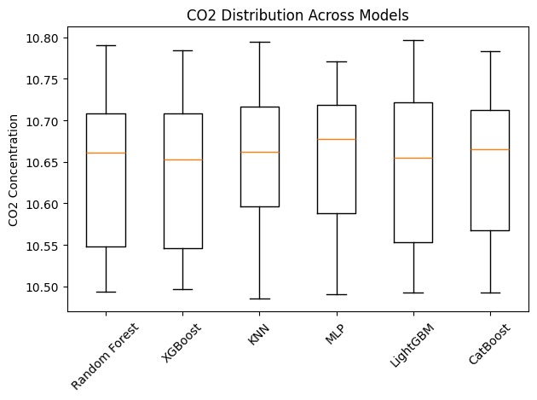

Figure 3. CO2 Distribution Across Models
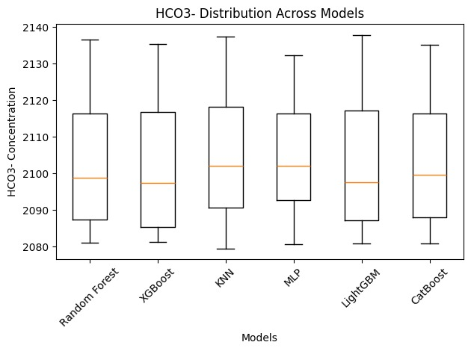

Figure 4. HCO3 Distribution Across Models

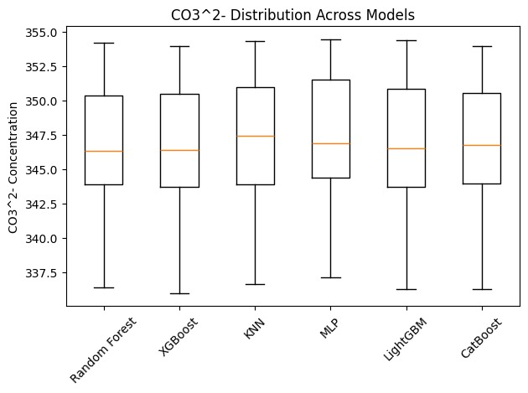

Figure 5 CO3² Distribution Across Models

6.4 Evaluation of Results

The performance of models is evaluated using R², RMSE, and MAE.

Table 2. Model Performance Comparison
Sl. No. | Model | R² | RMSE | MAE
1 | Random Forest | 0.971505 | 0.731134 | 0.469883
2 | XGBoost | 0.963358 | 0.829085 | 0.519421
3 | KNN | 0.952563 | 0.943337 | 0.609093
4 | CatBoost | 0.979197 | 0.624702 | 0.444586
5 | MLP | 0.890837 | 1.431027 | 1.091228
6 | LightGBM | 0.969000 | 0.762590 | 0.479954

6.5 Graphical Representation

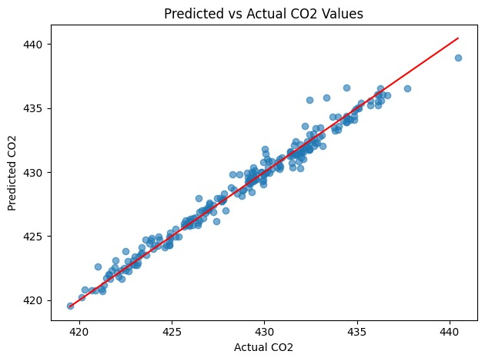

Figure 6. Predicted vs Actual CO2 Values

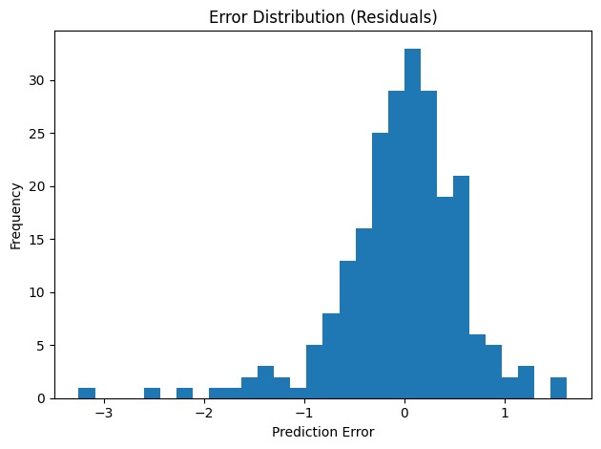

Figure 7. Error Distribution

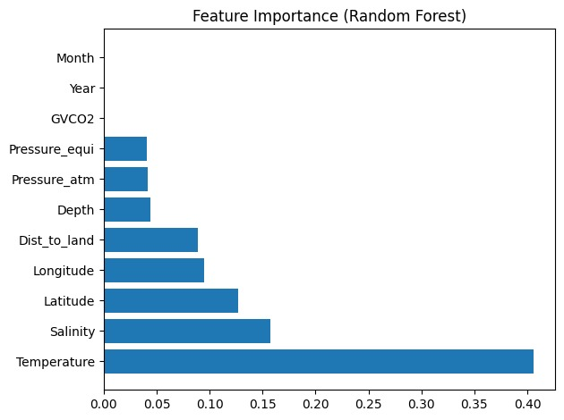

Figure 8. Feature Importance

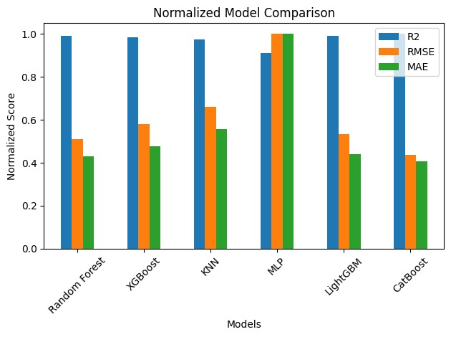

Figure 9. Normalized Model Comparison

Suggested graphs:
- R² comparison bar chart
- RMSE & MAE comparison graph
- Actual vs Predicted values graph

Explanation:
The graphs clearly indicate that Random Forest performs better compared to other models. XGBoost also shows strong performance, while Decision Tree has higher error values.

CHAPTER 7

CONCLUSION AND FUTURE WORK

This research shows that machine learning techniques, particularly ensemble algorithms like Random Forest (RF) and eXtreme Gradient Boosting (XGB), can provide robust and effective predictions of CO solubility in brine systems. These methods have been able to model the complex non linear relationships between temperature, salinity and CO partial pressure well. Random Forest produced the highest R² values, while XGBoost had the lowest root-mean-square error (RMSE), which indicates that both models show strong predictive power. Compared to traditional approaches based on experiment or thermodynamic calculations, these data-driven methods have the potential to produce more accurate, faster and computer-efficient solutions to problems related to CCS. Future research could continue exploring the potential for improving predictive accuracy through additional machine learning techniques (such as support vector machines, artificial neural networks, and physics-informed neural networks) and applying hyperparameter optimization and larger and more diversely-sampled training data to improve the robustness of the two models used in this study. Further, by applying machine-learning techniques and physical models together, and using real-time CCS systems, these methods may also im prove the quality of predictions and the practical applicability of their results.

REFERENCES

[1] SOCAT, Surface Ocean CO₂ Atlas (SOCAT), Version 2024, 2024.

[2] S. Davoodi et al., “Machine learning models for predicting CO₂ solubility in various brine systems.”

[3] H. Vo Thanh et al., “Knowledge-based machine learning techniques,” Applied Energy, 2022.

[4] S. Davoodi et al., “Machine learning predictions of solubility,” Expert Systems with Applications, 2023.

[5] Y. Chen et al., “Density-driven convection for CO₂ solubility trapping,” Geotechnics, 2023.

[6] J. M. Nordbotten et al., “Injection and storage of CO₂ in saline aquifers.”

[7] N. Spycher and K. Pruess, “CO₂–H₂O mixtures,” Geochimica et Cosmochimica Acta, 2005.

[8] M. Safaei-Farouji et al., “Predicting carbon dioxide trapping efficiency,” Journal of Cleaner Production, 2022.

[9] P. O. Longe et al., “Predicting CO₂ and H₂ solubility,” Energies, 2024.

[10] L. Truche et al., “Direct measurement of CO₂ solubility,” Geochimica et Cosmochimica Acta, 2016.

[11] B. Sun et al., “Prediction method of solubility,” Journal of Contaminant Hydrology, 2022.

[12] R. R. Ratnakar et al., “Computational strategy to estimate CO₂ solubility,” Applied Energy, 2023.

[13] B. Liu and A. Riazi, “Evaluation of machine learning frameworks,” Lithosphere, 2022.

